**Front End:**

Fonts:

H1: 'Kaisei Tokumin', 56px

H2: 'Kaisei Tokumin', 45px

H3: 'Kaisei Tokumin', 35px

B1: Comfortaa, 20px

B2: Comfortaa, 17px

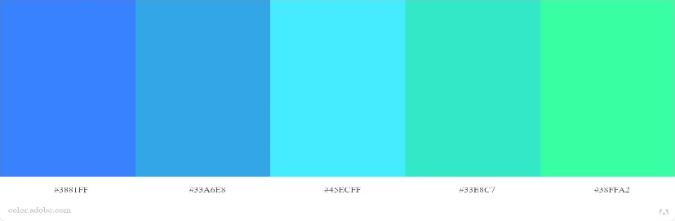Color:

/* Color Theme Swatches in Hex */

.My-Color-Theme-1-hex { color: #3881FF; }

.My-Color-Theme-2-hex { color: #33A6E8; }

.My-Color-Theme-3-hex { color: #45ECFF; }

.My-Color-Theme-4-hex { color: #33E8C7; }

.My-Color-Theme-5-hex { color: #38FFA2; }

/* Color Theme Swatches in RGBA */

.My-Color-Theme-1-rgba { color: rgba(56, 129, 255, 1); }

.My-Color-Theme-2-rgba { color: rgba(51, 166, 232, 1); }

.My-Color-Theme-3-rgba { color: rgba(69, 236, 255, 1); }

.My-Color-Theme-4-rgba { color: rgba(51, 232, 199, 1); }

.My-Color-Theme-5-rgba { color: rgba(56, 255, 162, 1); }

/* Color Theme Swatches in HSLA */

.My-Color-Theme-1-hsla { color: hsla(217, 100, 60, 1); }

.My-Color-Theme-2-hsla { color: hsla(201, 79, 55, 1); }

.My-Color-Theme-3-hsla { color: hsla(186, 100, 63, 1); }

.My-Color-Theme-4-hsla { color: hsla(169, 79, 55, 1); }

.My-Color-Theme-5-hsla { color: hsla(151, 100, 60, 1); }

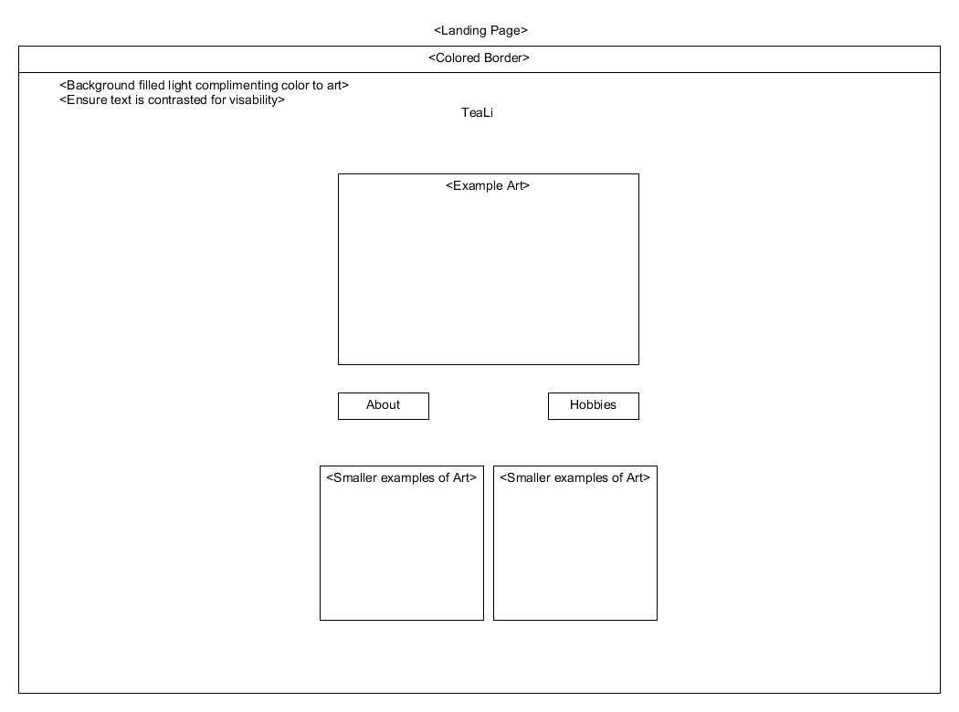**Wireframes:**

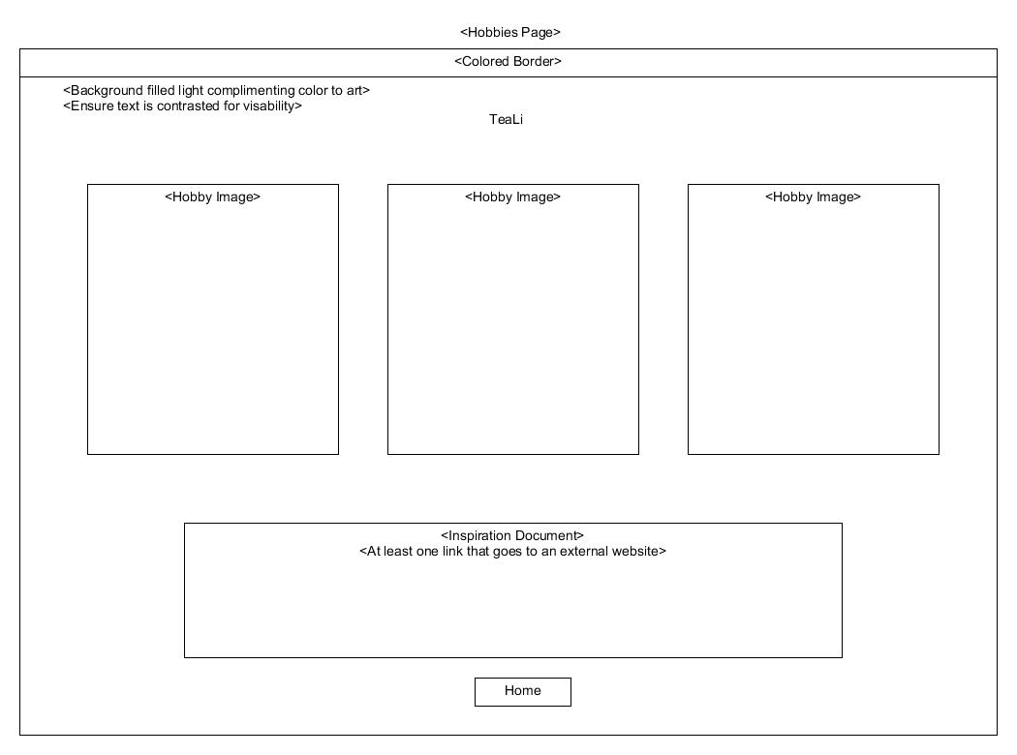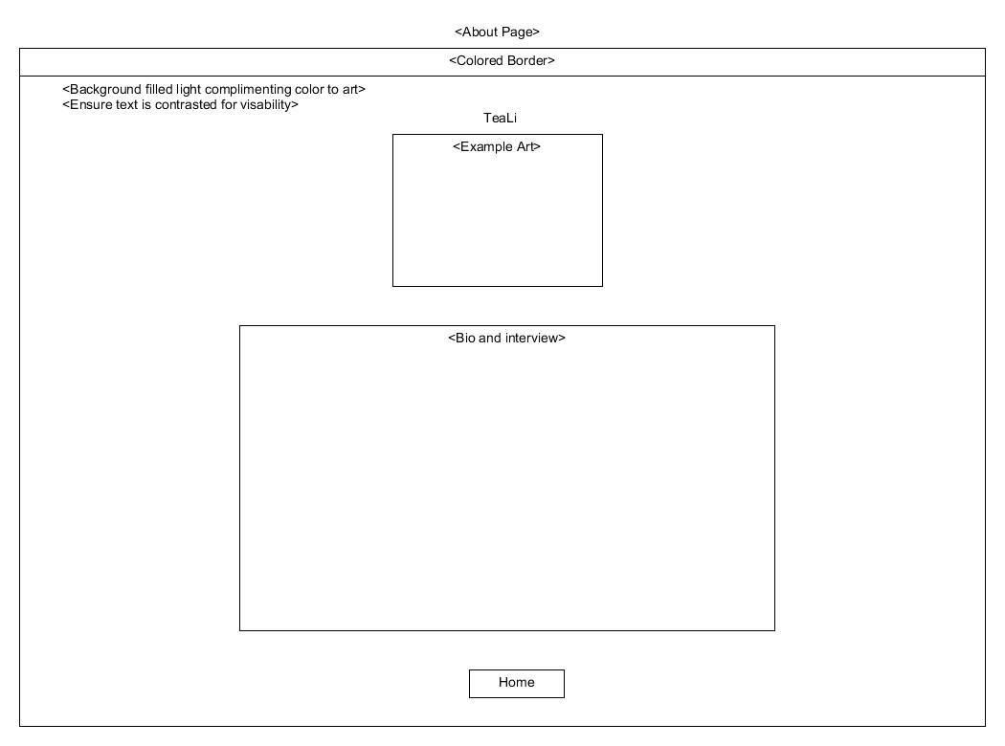

**Interview:**

1. What are your goals?
   1. To have fun in my adult life by doing cool jobs and making art.
2. What would be a dream job?
   1. To be a ranch hand and/or freelance artist.
3. Do you want to go to college or a tech program?
   1. I'd like to go to college but it's not a main priority.
4. What state would you want to move to?
   1. Texas.
5. What are your favorite hobbies?
   1. Drawing and looking at bones.
6. Why are you interested in that?
   1. I like drawing because it's fun to learn. I like bones cuz it's neat that they came from a real, live things that doesn't exist anymore.
7. What is your favorite food?
   1. I like gyros and kofta.
8. What do you do for fun?
   1. Skate, research animal preservation.
9. Are there any games you enjoy playing?
   1. I like Borderlands but don't play it often. I like Majesty, Scythe, Fluxx. I don’t know.
10. Why is that?
    1. Usually, I'm more a fan of the art and graphics than the plot of the game.

**Inspiration document:**

**Drawing**: TeaLi has gone from simple sketches of generalized features to pencil sketching and pen lining, to full color images of characters. Recently TeaLi has been looking digital means to continue progressing their art. TeaLi still researches drawing types and methods as well as different techniques. TeaLi's characters are also changing as they find new concepts and ideas to render on paper. Recently TeaLi has taken to learning to apply similar techniques to a digital framework in order to utilize more tools in their drawings.

**Animal** **preservation**: Beginning with finding remains during hikes and camping, TeaLi has an interest in animals and the materials they leave behind. Through some of these TeaLi has found another medium in which to express themselves artistically. This interest started off picking feathers during walks. After a few camping trips and coming across skeletons of various animals, TeaLi started picking up jaw bones, skulls, or leg bones as they could. Eventually those bits and pieces were held in containers until TeaLi got the idea they could arrange them into a larger piece. TeaLi started looking into state and local laws regarding picking up road kill in order to scavenge bones for possible larger pieces or to assemble them back into a skeleton of the animal.

**Heading out:** TeaLi has shown an interest in working seasonal jobs or other easy to travel style of jobs. TeaLi would like to get back down to Texas. Besides that they would like to see about being able to travel while working these seasonal jobs. This way they can see more of the country and get to interact with the local people more so than you would during a vacation.

**Bio:**

TeaLi Morillo-Fox is not the typical type of teenager you would see in a Midwestern town. Having spent most of their younger years in central Texas, TeaLi has spent a good amount of time camping, hiking, geocaching, and otherwise enjoying the nature. Because of their time outside TeaLi has learned about animals, their habitat, and how humans affect them. TeaLi is interested in not only how animals lived but how they are after they die. TeaLi has been taking an interest in animal preservation and has been looking into the legal requirements for obtaining animal material that would become a road hazard or otherwise disposed of by the city.

As far as their long term goals, TeaLi would like to move back to Texas. After de-tasseling, they have shown an interest in seasonal work. Especially work that would allow them to travel. TeaLi is currently interested in being able to see more of the country and looking at possibly traveling even further.

When TeaLi isn't busy with school work or hanging out with friends, they can be found filling pages with drawings and exploring new concepts and techniques. TeaLi has also been looking into different avenues of art. Recently they have been looking at jewelry making, digital art, and possibly stained glass.

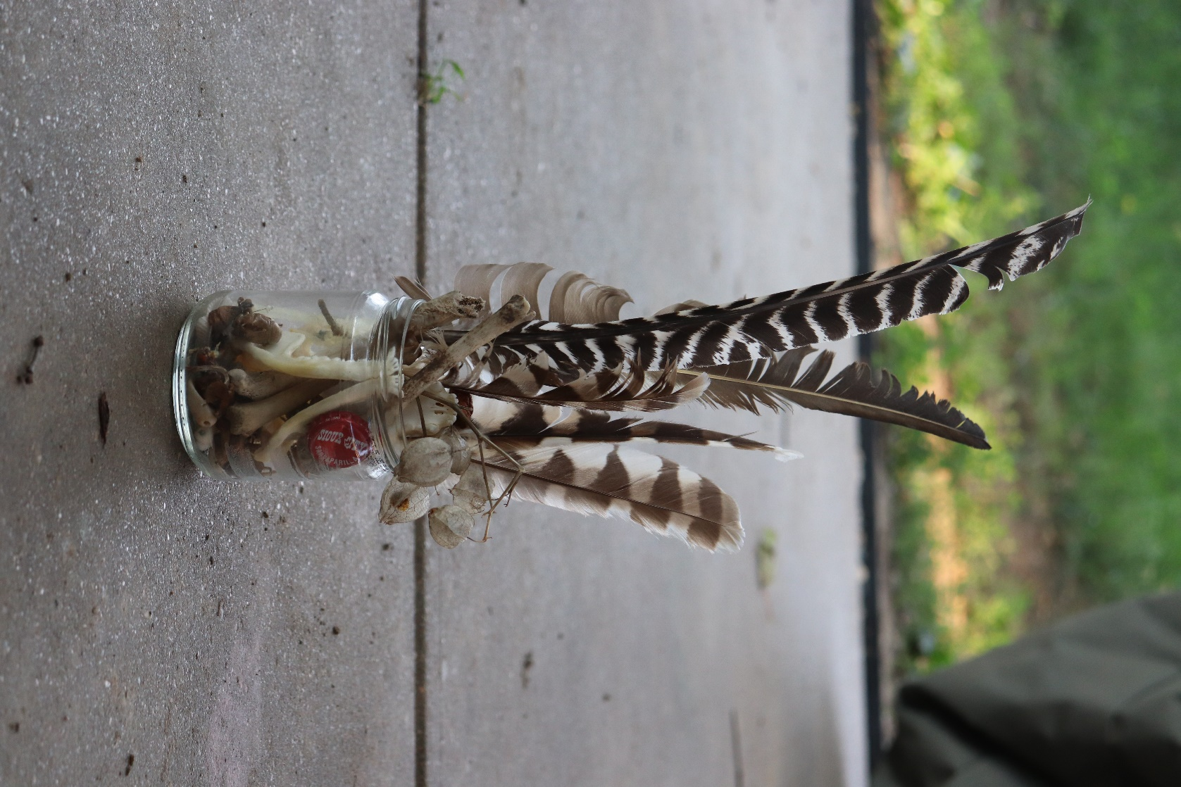 TeaLi also enjoys sitting down with their family and playing games. A couple of recent favorites have been Majesty and Scythe. When they are able to they also enjoy playing with their pets which include three cats and two dogs.

**Images:**

